CONGRATA PAGE 2026
Front Page

The world’s greatest challenges won’t be solved by one discipline, one region, or one perspective.
CONGRATA empowers trailblazers to cross boundaries, build connections, and create lasting economic, cultural, and community impact.
Our Vision
CONGRATA guides emerging thinkers to work across areas of knowledge, communities, and frontiers through exploration, innovation, international connectivity, collaborative learning, stewardship, and social entrepreneurship. By combining global experience with cross-disciplinary education, we support scholars to address pressing social concerns, strengthen the eco-system, and help build a more just, inclusive, and sustainable society; aiming to cultivate research excellence, and build scientific credibility.
Our Three Pillars
- Early Career transnational Mobility
- Rewarding Stewardship Development
- Social Entrepreneurship
CONGRATA Impact
- Young interdisciplinary STEM innovators and future leaders
- Partners in Academia, Corporations and Public Institutions
- Communities, countries, and regions
- Scholarly collaboration and meaningful transnational research experiences
Unlike traditional programs, CONGRATA mentors the next generation of interdisciplinary STEM innovators and globally minded leaders by integrating international mobility, cross-disciplinary collaboration, stewardship, and social entrepreneurship. This combined approach equips scholars to address urgent matters that span specialties, ethnicities, and geo-political barriers.
Credibility Snapshot
For over a decade, CONGRATA partnering with the University of California has advanced opportunities for first-generation STEM scholars, particularly women. As the founder of CONGRATA and co-founder of the Mexico Graduate Research and Education Program, have consistently witnessed the importance of fostering science scholars to enrich and expand their pathways toward scientific excellence. Through international mobility, they have explored new viewpoints, gaining experience in different research environments, broadening their perspectives beyond institutional boundaries. Returning refreshed and inspired, with new ideas, amplifying connections, and renewed enthusiasm to continue their demanding academic journeys to pursue new and meaningful opportunities for research and scientific excellence.
The experiences of our graduates speak to the transformative power of scientific mobility.
Their stories offer a firsthand perspective on how working and learning across borders can shape not only their research, but also their confidence, aspirations, vision for their scientific careers.
Beyond Our Own Boundaries: Graduate Experiences in Scientific Mobility
Our Engagement
Photos & Statements
- Partners
- Leadership
- Global reach
- Research network
Call to Action
Your support empowers tomorrow's scientists and leaders to create solutions that improve lives across communities, nations, and generations.
Become a Scholar • Partner with Us • Support Our Mission
Menu Sections: About Us, Our Programs, Our Impact, Engage with Us

BAR MENU

About Us

The Challenge
Today’s first-generation professionals enter a workforce shaped by global competition that extends beyond institutional boundaries. Success now requires grounded, knowledgeable leaders who can think globally, collaborate across cultures, and turn expertise into sustainable impact.

Our vision
CONGRATA prepares the next generation of social entrepreneurs and STEM pioneers through transnational scientific mobility, stewardship development, and social entrepreneurship. We equip them to address local, regional, and global challenges, including climate change, misinformation and disinformation, biodiversity loss, public health, and economic inequality.

Founder's Inspiration

Every meaningful mission begins with a personal journey. CONGRATA was born from mine.

As an international female scholar in STEM, I experienced firsthand the excitement, uncertainty, and transformation that come with pursuing education beyond one's borders. My journey began as a chemical engineering intern at Celanese de México, where I spent several summers discovering not only the technical foundations of engineering but also the possibilities of a career dedicated to innovation. Later, in my work evaluating emerging technologies and patent applications at Mexico's National Council of Science and Technology strengthened my conviction that scientific discovery has the power to impact society, becoming the inspiration to pursue graduate studies abroad.

Yet I soon discovered that succeeding in graduate school required far more than academic excellence.

Behind every international scholar is a story of courage. It is the resilience to navigate unfamiliar educational systems, overcome cultural barriers, confront self-doubt, and persevere through moments of profound isolation. These experiences are rarely reflected on a résumé, yet they shape the leaders, innovators, and changemakers our world needs.

These experiences are transformational but also reveal a gap

Thriving first generation of scholars have extraordinary passion, determination for change and intellectual capacity but without the structured support needed to navigate the personal, cultural, and professional challenges of studying internationally. Too often, they face these obstacles alone. I began asking a simple question: What if every social entrepreneur and STEM scholar had access to the guidance, community, and tools needed not only to succeed academically abroad, but to truly flourish?

That answer became CONGRATA.

Our Programs
Scholars Global Mobility
The global mobility is offered to first generation early career of science graduate students, who are regularly enrolled in master’s and PhD academic programs at a recognized institution.
During a 60-day period, STEM mobility scholars take selected assignments with the purpose of observing and learning new approaches to problem solving and research, while exchanging knowledge and learning about other cultures’ ways of living, decision making and perceiving their technological and economic advancements.
During their stay abroad, Mobility scholars are expected to deepen their analytical thinking, strengthen essential cognitive, personal, and academic skills towards more assertive decision-making, personal growth and career projection. At the end of their journey, scholars submit a report to be evaluated for future mobility opportunities. Applications are submitted before May 2027.
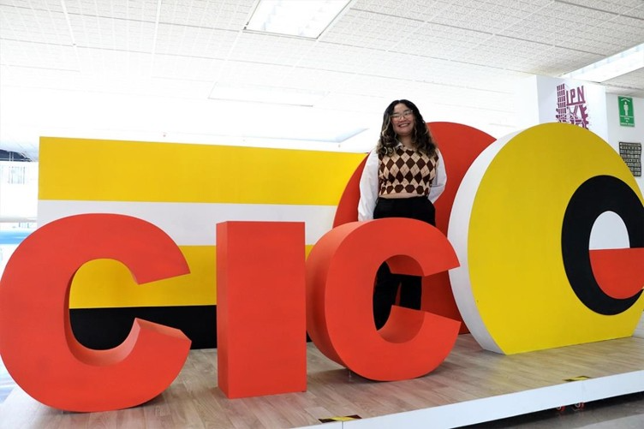
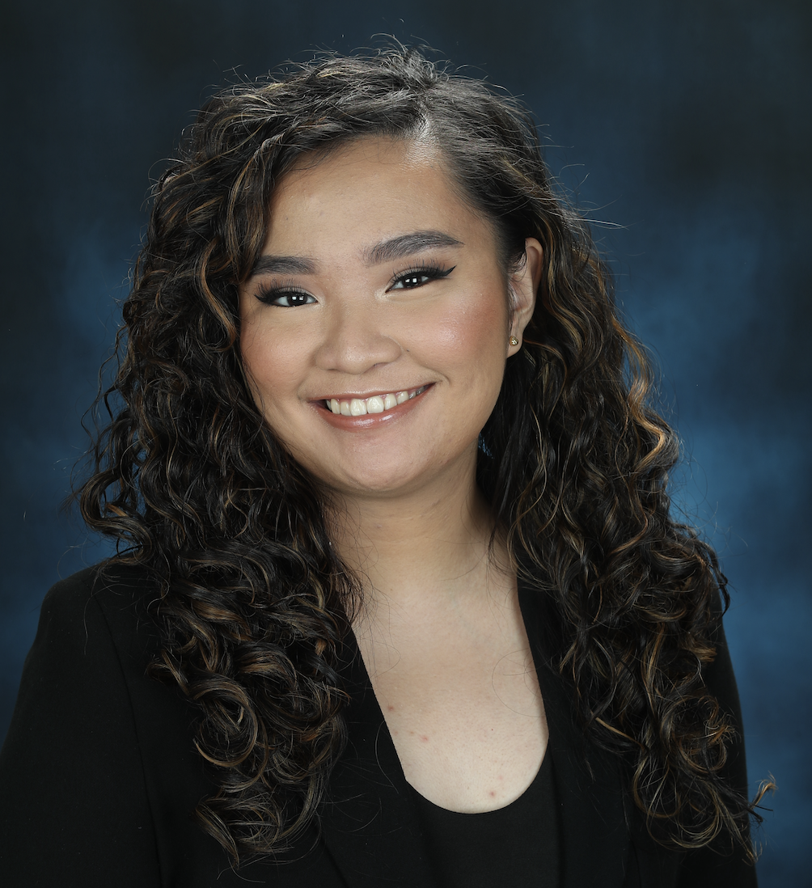

”My project about Data Analysis and Human Activity Modeling for Electricity and Solar Photovoltaic Electricity Generation at CIC-IPN in North of Mexico City under the guidance of Dr. Escamilla-Ambrosio and Dr. Salma Elmalaki,was an unexpected experience which enriched my perspective of the importance of my field of research and its significant applications” – Diana Gimena Romero


Alex Nguyen spent a summer at the Monterrey Institute of Technology and Higher Education, ITESM in Mexico. “Colleagues in Mexico welcome me with kindness and great hospitality. This positive environment made my research on Mutualistic Interactions in Heterogeneous Multi-Robot Systems broaden an unforgettable experience”

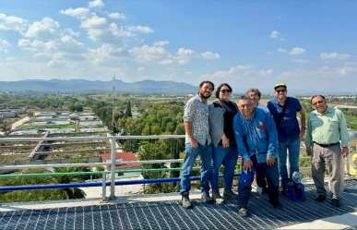


Research visiting at the Autonomous University of Aguascalientes, UAA
My study and assessing Aguascalientes’ Municipality Drinking and Industrial Water Quality Provisions, Management and Reuse, should be viewed as the initiation for a fruitful long-term collaboration. Moreover, the discussions, interviews, relationships, and reciprocal demonstrations of interest which developed from this first collaborative exchange were of demonstrable educational value to participating graduate students and faculty at both institutions. Therefore, I would like to thank UC Irvine, our collaborators at UAA, and the local authorities in Aguascalientes for facilitating this exchange of knowledge.-
Jon Liberzon at the Playa Los Arellanos WRRF.
Interested applicants can send their application with their curriculum vitae to: gimobility@ congrata.com
Colloquia

At CONGRATA life success is taken a holistic approach viewing professional occupation as a lasting path for intellectual achievement and personal fulfillment. Students also open to the public are offered ad-hoc insightful sessions relevant to their calling mission, personal growth and enriched societal interconnection.
Recognizing the importance of applying knowledge effectively, connecting with society, and meeting the demands of a professional career, CONGRATA fosters meaningful stewardship that supports personal growth and more fulfilling lives.

See the available session topics and content for more information.

Social Entrepreneurship

Through documentaries, mentorship and relevant dialog, CONGRATA scholars learn from social leaders and entrepreneurs about their journeys, motivations, experiences and what has made them impactful societal leaders.

Engage with Us!

